The task:
Create a database on MySQL, create several tables, create, modify, delete the records.
Create simple and complex queries.
Create database: shops

Tables:
■ Rozetka (id_r, name_r, id_com, price_r)
■ Allo (id_a, name_a, id_com, price_a)
■ Company (id_c, name_c)

Rozetka:
■ Kettle, Bosch, 1500
■ TV, Samsung, 5000
■ Smartphone, Samsung, 15,000
■ Smartphone, Apple, 20,000
■ Blender, Bosch, 500

Allo:
■ TV, Samsung, 10000
■ TV, Apple, 20,000
■ Kettle, Samsung, 250
■ Blender, Samsung, 600
■ Smartphone, Apple, 15,000

Company:
■ Bosch
■ Samsung
■ Magic
■ Apple

A task:
■ Make a simple selection for each table
■ Sort each table by company
■ Group table by name
■ Select the maximum price value for each table
■ Calculate the total cost of goods in each table
■ Make a selection of all smartphones from all tables (product name, price, company)
■ Make a selection of all Bosch products for all products table
■ Select Samsung products from all tables where price more than 600
■ Select smartphones worth more than 15,000

Language of execution: English.

Task execution

Step 1. Creation the “Shops” database
CREATE DATABASE Shops
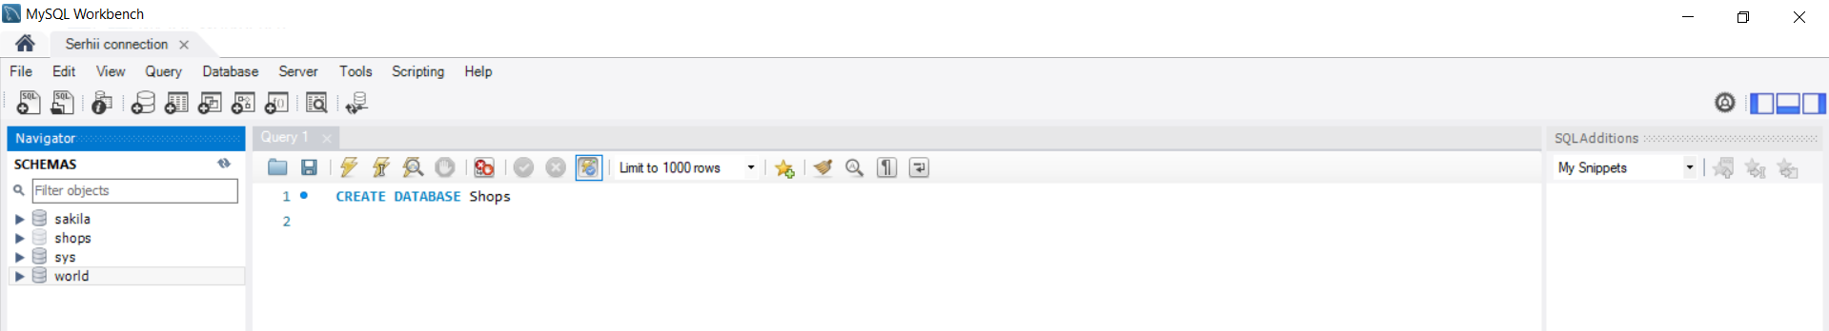
Step2. USE Shops
USE Shops;
Step 3. Creation tables
Table 1 (Company)
CREATE TABLE Company (
id_c int NOT NULL AUTO_INCREMENT,
name_c varchar(20),
PRIMARY KEY (id_c));
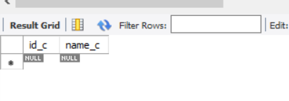
INSERT INTO Company (name_c) VALUES
('Bosch'),
('Samsung'),
('Magic'),
('Apple'),
('Nicon');
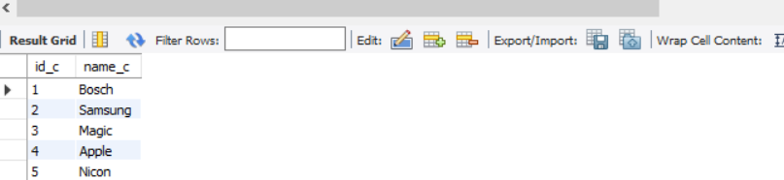

UPDATE Company SET name_c = 'Canon' WHERE id_c = 5
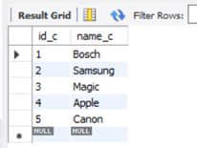
Table 2 (Rozetka)
CREATE TABLE Rozetka (
id_r int NOT NULL AUTO_INCREMENT PRIMARY KEY,
name_r varchar(20),
id_com int,
price_r decimal,
FOREIGN KEY (id_com) REFERENCES Company(id_c));
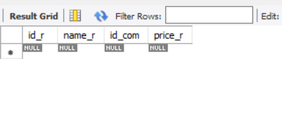
INSERT INTO Rozetka (name_r, id_com, price_r) VALUES
('Kettle', 1, 1500),
('TV', 2, 5000),
('Smartphone', 2, 15000),
('Smartphone', 4, 20000),
('Blender', 1, 500);
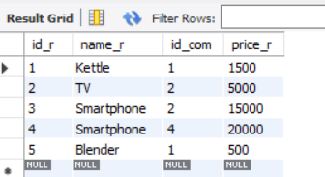

Table 3 (Allo)
CREATE TABLE Allo (
id_a int NOT NULL AUTO_INCREMENT PRIMARY KEY,
name_a varchar(20),
id_com int,
price_a decimal,
FOREIGN KEY (id_com) REFERENCES Company(id_c));
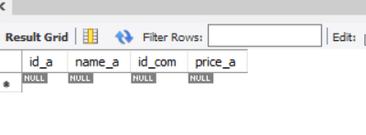
INSERT INTO Allo (name_a, id_com, price_a) VALUES
('TV', 2, 10000),
('TV', 4, 20000),
('Kettle', 2, 250),
('Blender', 2, 600),
('Smartphone', 4, 15000);
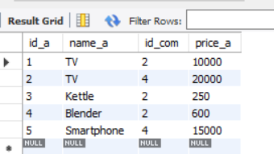

Table 4 (Rozetka2)
CREATE TABLE Rozetka (
id_r int NOT NULL AUTO_INCREMENT PRIMARY KEY,
name_r varchar(20),
id_com int,
price_r decimal,
FOREIGN KEY (id_com) REFERENCES Company(id_c));

Step 4. Deleting the records
Delete a raw from the Company table
DELETE FROM Company WHERE id=5;
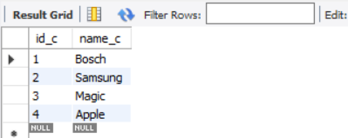

Delete the Rozetka 2 table
DROP TABLE Rozetka2;
Step 5. Making a simple selection for each table
The Company table
SELECT * FROM Company;
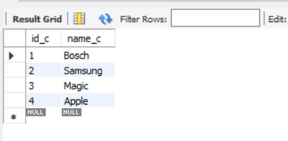
The Rozetka table
SELECT name_r FROM Rozetka WHERE id_r BETWEEN 2 AND 5;
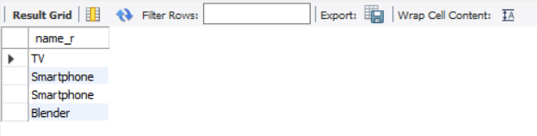

The Allo table
SELECT * FROM Allo WHERE price_a > 500;
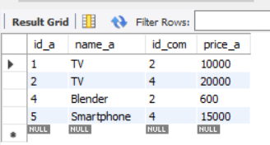
Step 6. Sorting each table by company
The Company table
SELECT * FROM Company
ORDER by name_c;
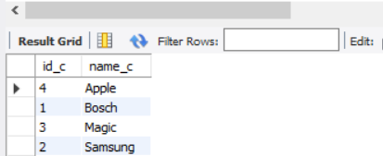

The Rozetka table
SELECT * FROM Rozetka
INNER JOIN Company ON Rozetka.id_com = Company.id_c
ORDER BY name_c;
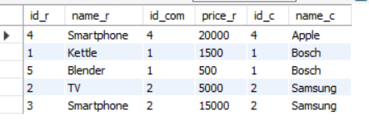
The Allo table
SELECT * FROM Allo
INNER JOIN Company ON Allo.id_com = Company.id_c
ORDER BY name_c DESC;
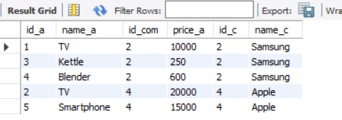

Step 7. Grouping table by name

The Company table

SELECT COUNT(id_c),name_c FROM Company
GROUP BY name_c;
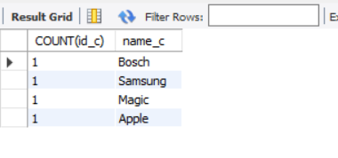
The Rozetka table
SELECT COUNT(id_c), name_c FROM Company
JOIN Rozetka ON Rozetka.id_com = Company.id_c
GROUP BY name_c;
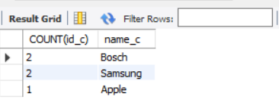
The Allo table
SELECT COUNT(name_a) FROM Allo GROUP BY name_a
HAVING name_a LIKE 'T%'
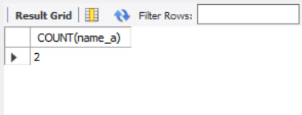

Step 8. Selecting the maximum price value for each table

The Rozetka table

SELECT MAX(price_r) AS MAXPRICE_R FROM Rozetka
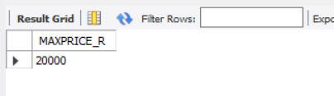
The Allo table

SELECT MAX(price_a) AS MAXPRICE_a FROM Allo
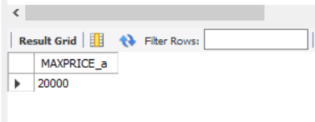
Step 9. Calculating the total cost of goods in each table

The Rozetka table

SELECT SUM(price_r) AS Totalcost_r FROM Rozetka;
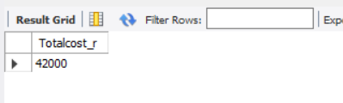
The Allo table

SELECT SUM(price_a) AS Totalcost_a FROM Allo
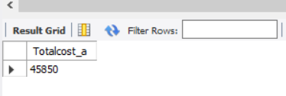
Step 10. Making a selection of all smartphones from all tables (product name, price, company)
SELECT name_r, price_r, name_c FROM Rozetka JOIN Company ON Rozetka.id_com=Company.id_c
WHERE rozetka.name_r LIKE 'Smartphone'
UNION SELECT name_a, price_a, name_c FROM Allo JOIN Company ON Allo.id_com=Company.id_c
WHERE Allo.name_a LIKE 'Smartphone'
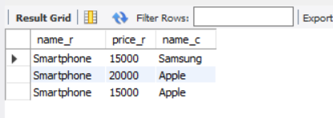
Step 11. Making a selection of all Bosch products for all products tables

SELECT name_r, price_r, name_c FROM Rozetka JOIN Company ON Rozetka.id_com=Company.id_c
WHERE Company.name_c LIKE 'Bosch'
UNION SELECT name_a, price_a, name_c FROM Allo JOIN Company ON Allo.id_com=Company.id_c
WHERE Company.name_c LIKE 'Bosch'
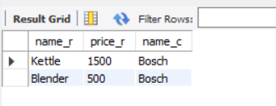
Step 12. Selection Samsung products from all tables where price more than 600

SELECT name_r, price_r, name_c FROM Rozetka JOIN Company ON Rozetka.id_com=Company.id_c
WHERE Company.name_c LIKE 'Samsung' AND Rozetka.price_r > 600
UNION SELECT name_a, price_a, name_c FROM Allo JOIN Company ON Allo.id_com=Company.id_c
WHERE Company.name_c LIKE 'Samsung' AND Allo.price_a > 600
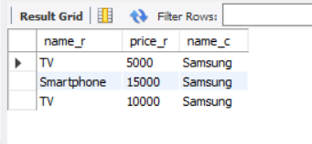
Step 13. Selection smartphones from all tables where price more than 15000

SELECT name_r, price_r, name_c FROM Rozetka JOIN Company ON Rozetka.id_com=Company.id_c
WHERE name_r LIKE 'Smartphone' AND price_r > 15000
UNION SELECT name_a, price_a, name_c FROM Allo JOIN Company ON Allo.id_com=Company.id_c
WHERE name_a LIKE 'Smartphone' AND price_a > 15000

